FACULTY
DEPARTMENT:- CHEMISTRY
NAME:- Dr Manoj Kumar Roy
DIGITAL PHOTOGRAPH:.
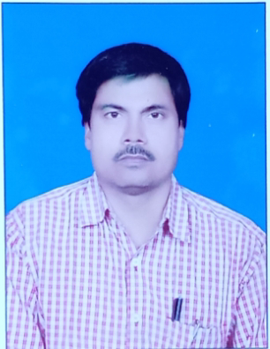
DESIGNATION: | Assistant Professor
DATE OF JOINING THIS COLLEGE: | 26.07.2011
TEACHING EXPERIENCE [at UG & PG level only]: | UG-13.5yrs,PG-9yrs
CONTACT NO.: | 9771111906
EMAIL ID: | drmanojkumarroy@gmail.com
ACADEMIC QUALIFICATIONS [PG & above only]: | M.Sc.,Ph.D
SPECIALIZATION/RESEARCH AREA: | Organic chemistry
SUPERVISING RESEARCH SCHOLARS/ PURSUING RESEARCH:

RESEARCH PAPERS/ARTICLES: | - Spectroscopic studies on macrocyclic Metal(II) complex,Asian journal of physics vol6(1997)No4  - Copper(II) complexes with Schiff base ligand 1,2-Diphenyl-1,2-alkyl-iminoethane-1-one-oxime,Asian journal chem Vol10 (1998)  - Micellar effect on fermentative production of Citric acid Journal chemtracks19(1)103-06,2017 ISSN 0973-239X Impact factor:4.950
EDITED/AUTHORED BOOKS:

AFFILIATION/ASSOCIATION WITH JOURNALS, etc.:

MEMBERSHIP/ATTACHMENT WITH DIFFERENT ASSOCIATIONS/INSTITUTIONS/BODIES/BOARDS: | Member of Board Jamshedpur women's College
ACHIEVEMENTS/FELICITATIONS/AWARDS RECEIVED:

ANY OTHER RELEVANT INFORMATION:

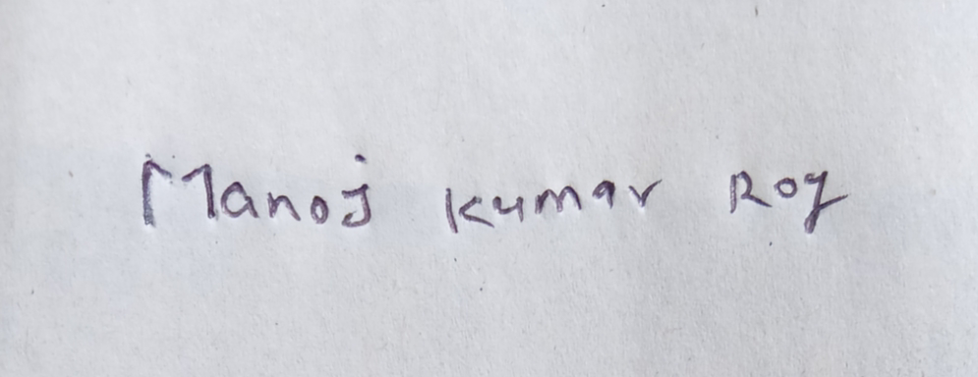
[SIGNATURE]

